|  |  |
| --- | --- |
|  | **Lab 05** |
| **Topic** | **Variables Inputs and Different Data types** |
| **Objective** | * Learning how to use variables. * Learning different data types input and output format |

**Note:** If you haven't already set up the environment to run C++ on your computer, visit Install C++ on Your Computer.

**Some Theory Review:**

The smallest individual unit of any program written in any language is called a token. C++’s tokens are divided into special symbols, word symbols, and identifiers. Following are some of the special symbols:

**Special symbols:**

Special symbols are the operator which are used to perform different operations like:

1. Arithmetic operators (+, -, *, /, %)
2. Logical operators (&&, ||, !)
3. Relational operators (>, <, >=, <=, ==, !=)

**Word symbols:**

Word symbols are the reserve words, which are used for different purpose. Reserve word are also known as key words.

Some of the commonly used key words are: int, float, double, char, void, return, if, else, while, for.

**Identifiers:**

C++ identifier consists of letters, digits, and the underscore character (_) and must begin with a letter or underscore, no other symbols are permitted to form an identifier. C++ is case sensitive—uppercase and lowercase letters are considered different. Thus, the identifier NUMBER is not the same as the identifier number. Similarly, the identifiers X and x are different. It’s a good practice to define meaningful identifier name, like if u need to store salary of a person than identifier name should be salary not a, b or c.

**Data Type:**

Data type is a set of values together with a set of allowed operations. Integral, which is a data type that deals with integers, or numbers without a decimal part. Floating point, which is a data type that deals with decimal numbers. Some of the data types which are commonly used are: integer(int), floating point(float), character(char), Boolean(bool).

**How to define an identifier?**

Whenever we use an identifier first we need to define it otherwise system creates a syntax error (undefined identifier used). So we need to learn how to create an identifier.

**The generic way of define an identifier is:** dataType IdentifierName;

When we declare an identifier it holds a value which is not assigned by user so for user this value is considered as garbage value. So, it is a good practice to assign a value to an identifier at the time of creation which is called initialization.

**Initialization statement:**

Assigning a value at the time of declaration of a variable is called an initialization statement.

**The generic way of initialize an identifier is:** dataType IdentifierName = value;

In case of integer, float, double:

int noOfStudentsInClass=45;

float averageOfClass=60.5;

double length=5; or double length=6.85;

but in case of character and boolean the way of initialization is different.

In case of character assigned value is written in single quotes.

char grade=’A’;

In case of Boolean assigned value is written as true or false. But we can also write it as 0 or 1 form. 0 represent as false and 1 represent as true.

bool isNumberFound=true or bool isNumberFound=1;

**Can we change the value of an identifier?**

Yes, we can change the value of an identifier. There are multiple ways of doing this. We can change the value by assigning method and input method.

**Assigning method:**

There are two ways which are used as assigning method assigning value and assigning another identifier.

**Assigning a value:**

Identifier= value;

**Assigning an identifier:**

Identifier=identifier;

**Is there any difference between assigning statement and initialization statement?**

Yes, in initialization we assign a value at the time of creation of an identifier. On another hand in assigning statement we assign a value to an already defined identifier.

**Let’s do some practice:**

**Instructions:**

* Just be yourself, don’t copy.
* Try hard to write a program.
* Write comments in each program.

**Exercises:**

1. Write a program that takes from user an integer value between 2 and 20, and the prints its table.

Sample output:

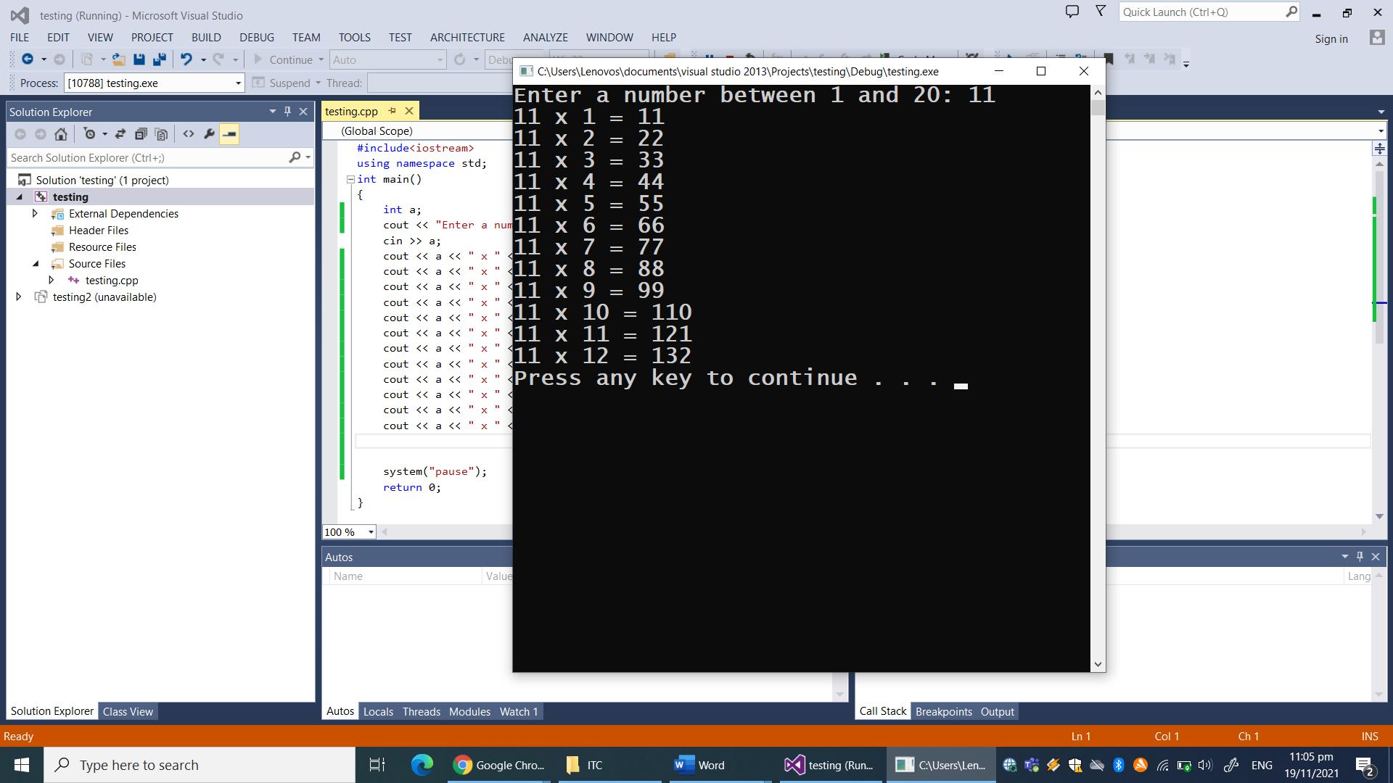

2. Write a program that takes from user an integer value and the prints its character value according to ASCII table.

Sample output:

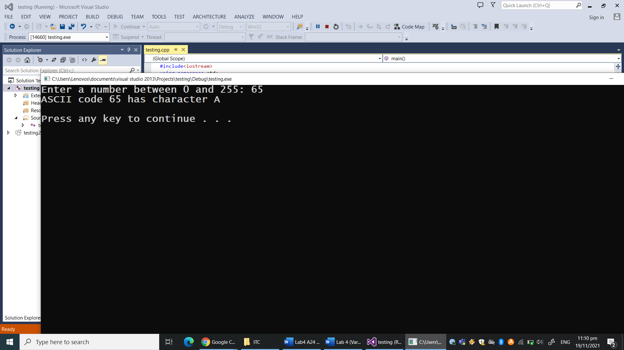

3. Write a program that takes from user character value and the prints its integer value according to ASCII table.

Sample output:

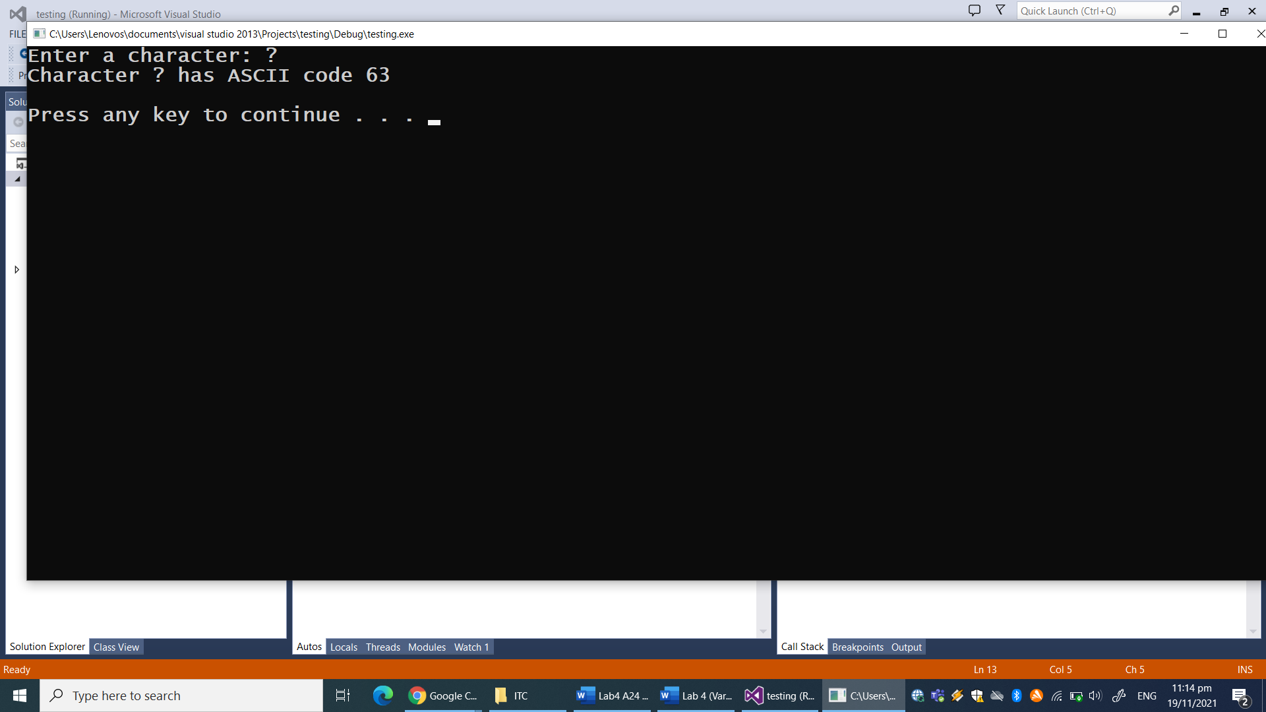

4. Write a program that takes input temperature in degree Centigrade from the user and convert it into degree Fahrenheit.

Sample output:

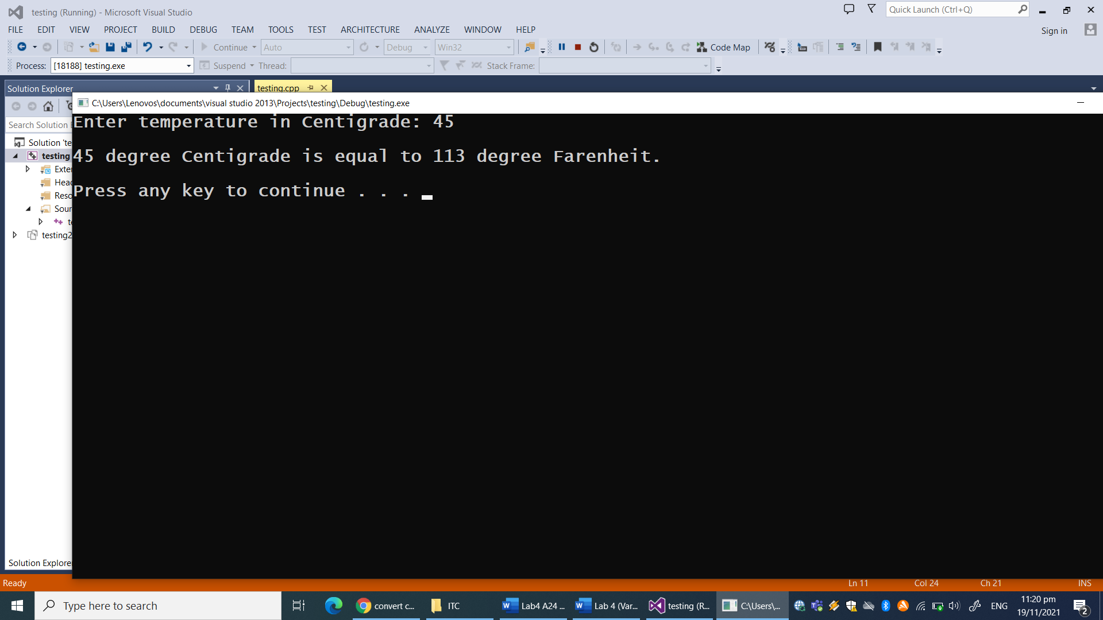

5. Write a program that takes input 2 numbers from the user and then print its sum, difference, product, quotient and reminder.

Sample output:

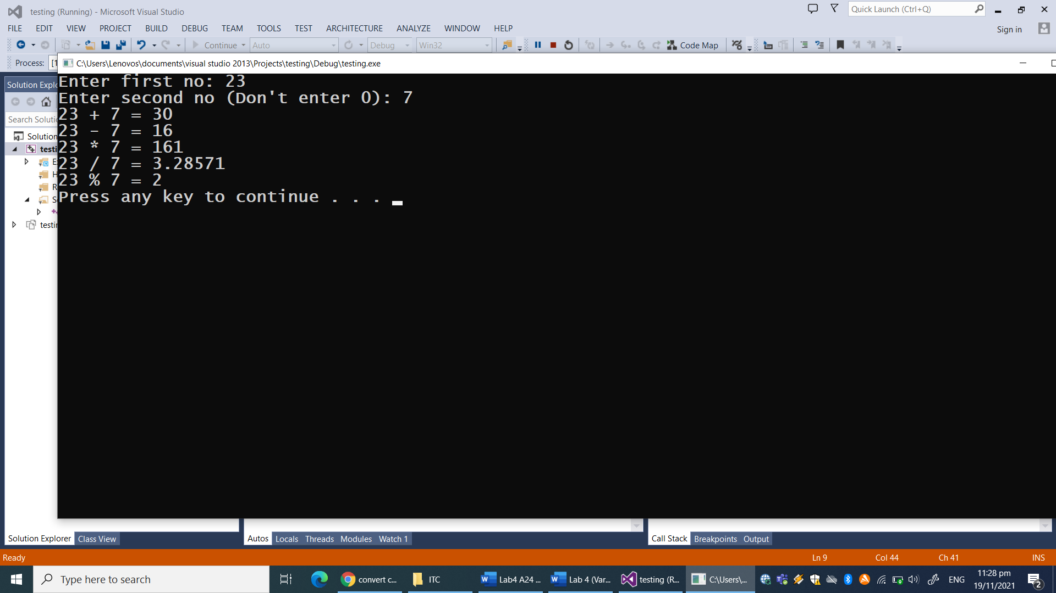

6. Type the code and observe the output. Write in comments of your code what is the sizeof( ) function doing?

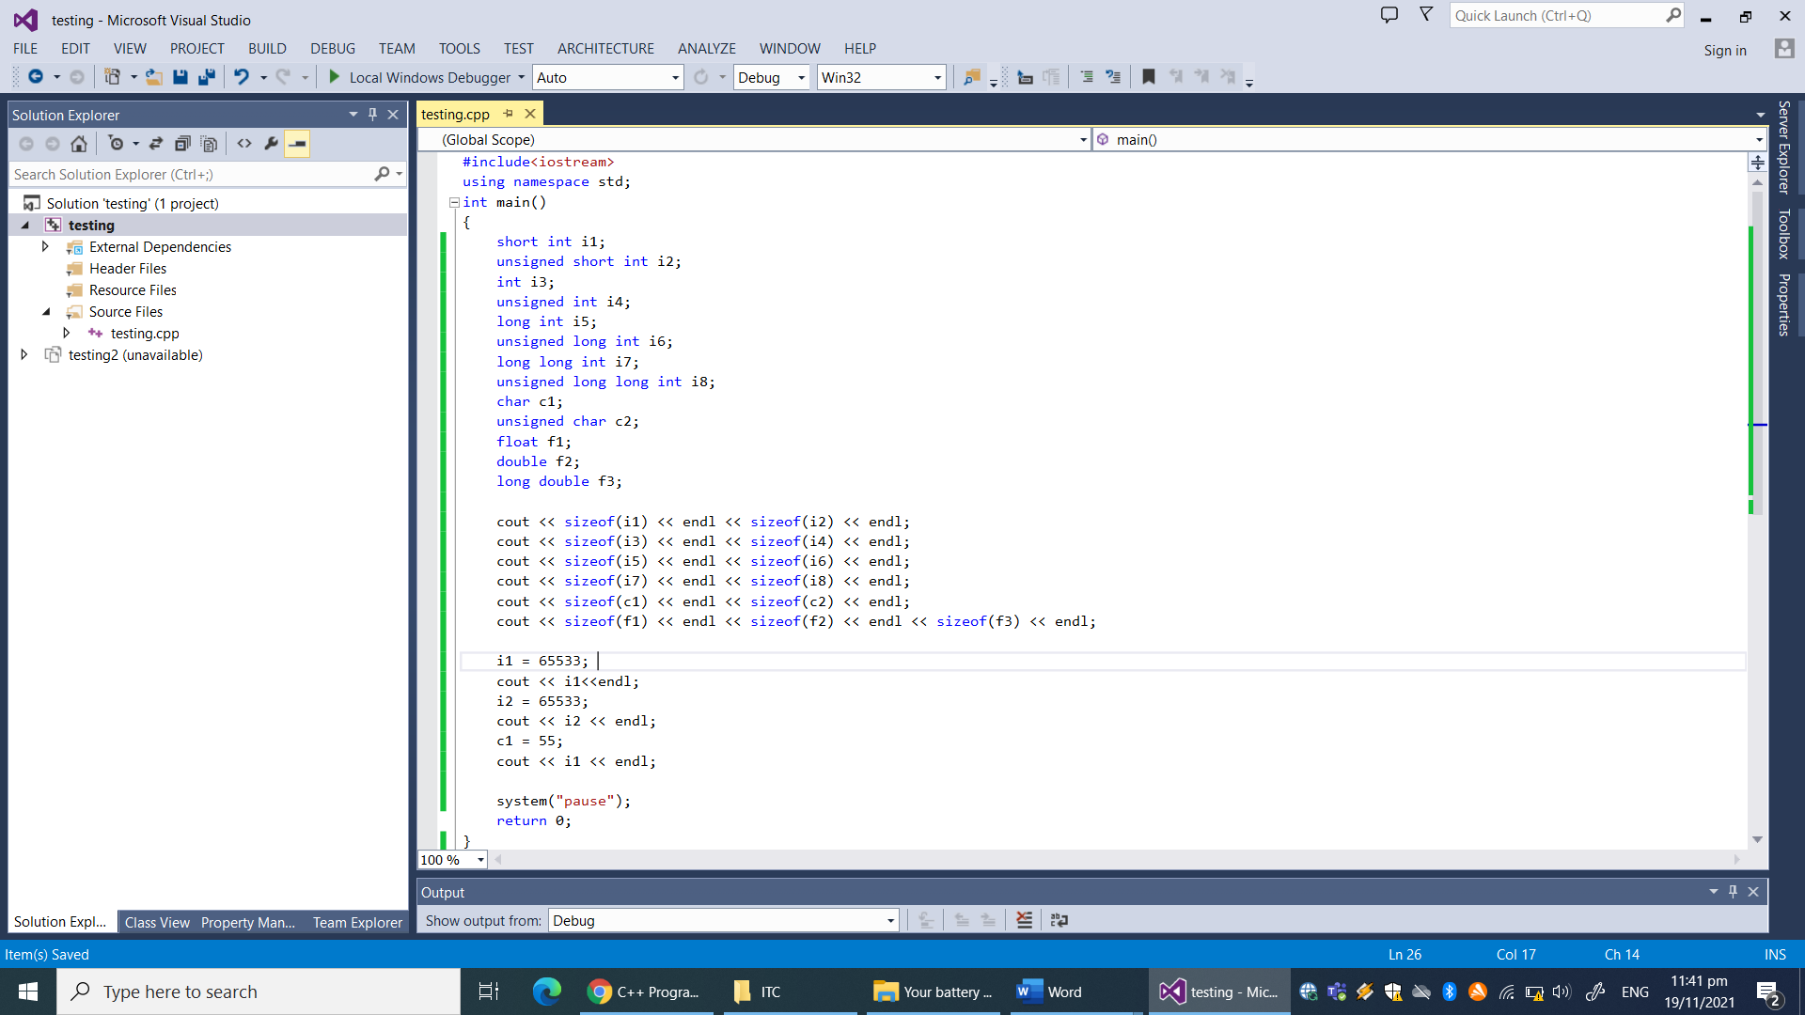

7. Type the code and observe the output. Write in comments at the start of the code, what is the purpose of this C++ program?

